CS 5180 Exercise – 3
Gopisainath Mamindlapalli

1)
a)
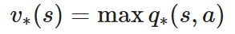
b)
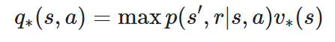
c)
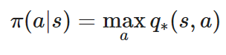
d)
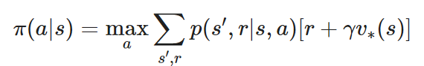
e)
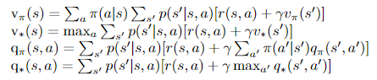

2)
a) When we analyse a scenario where we are in state s and both of the actions a1 and a2 indicated by the policy π(a∗s) lead to the same state s} (assuming s} is a terminal state and there are numerous paths to get it), a slight problem with the policy iteration method is shown. The policy may continuously switch between these acts in such a case, which might keep the algorithm from convergent. The second-to-last line of the algorithm, which determines whether the previous action π(s) is equivalent to the new action, is problematic. It does this by setting the "policy-stable" variable to "fails." The problem of oscillation between equally advantageous policies is not addressed by this tick.
It is important to substitute a stronger condition for this line in order to solve this issue. We should compare the values that old and new activities provide, rather than just confirming their inequality. Stability in policy is indicated if these levels remain constant. The following is the revised condition: In the event when vpi{(s) = vpi(s), "policy-stable" ought to be set to "true." With this modification, the algorithm will be able to better handle policy oscillation and converge.

b) Since value iteration doesn't explicitly switch between actions, it provides a solution to the issue of policy oscillation seen in policy iteration. Even yet, when actions have comparable value estimates, value iteration may still encounter value oscillations. One popular approach to this problem is to apply a halting condition that determines whether the difference between successive value estimations for all states is smaller than a small positive constant, ϵ. This helps keep the value function from unnecessarily oscillating and guarantees that the value estimates have stabilised within a narrow range. The particular problem and the required level of precision determine which value of ϵ to choose. In conclusion, value iteration can experience oscillations in values, but this is not the same as policy oscillation in policy iteration. By using the previously discussed approach, these oscillations can be lessened and ultimately the optimal value function will be reached. Algebraically,
If |V_(k+1) (s)- V_k (s)|<ϵ for all states s, then halt and provide Vk+1.

3)
a)
Policy Evaluation:
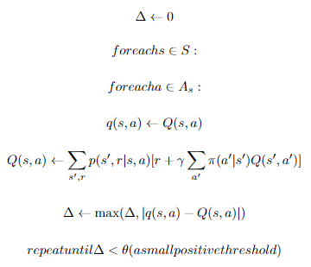
Policy Improvement:
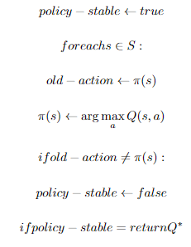

b)

4)
a) Since there is a cost associated with each minute the agent spends in "state x" and "state y," they are motivated to get to "state z" as soon as possible. But there is an issue. The activity (let's call it "action c") that can get them to "state z" is not particularly effective and rarely succeeds.
Therefore, the agent's task is to determine the shortest route to "state z" while minimising expenses along the way. This is what it ought to do:
1. The easiest approach to go to "state z" from "state x" is to perform "action c."
2. Rather than trying to move straight to "state z," it could be wiser to start with "action b" to return to "state x" (where it's preferable to wait for an opportunity to get to "state z"). This option in "state y” is a bit complex because it entails balancing the cost of waiting with the better likelihood of eventually reaching to "state z"

b)
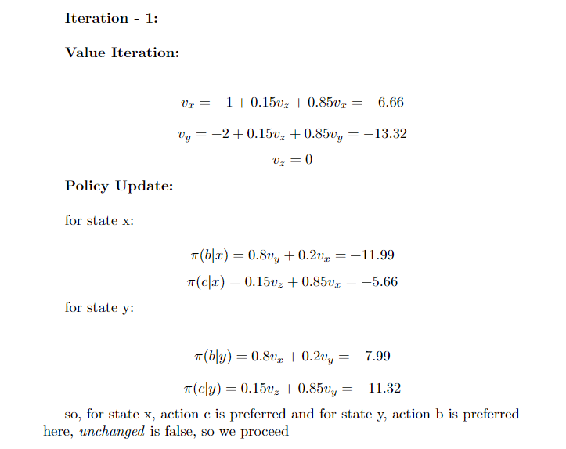
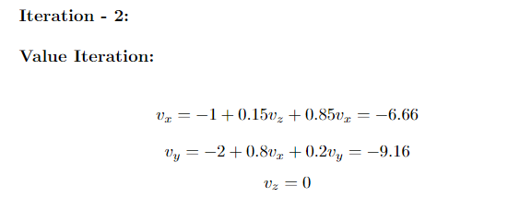

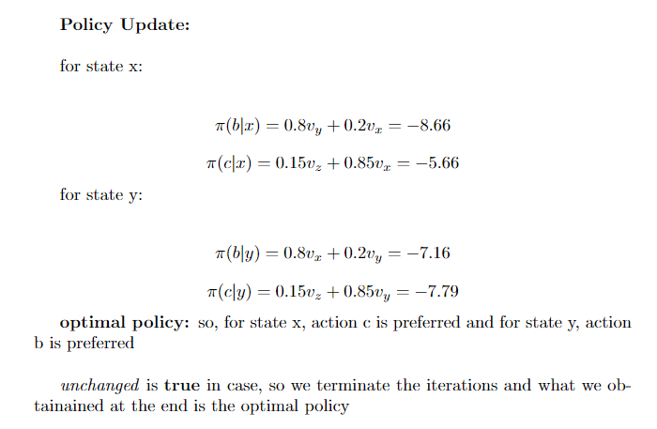

c) We begin with a basic strategy in which action "a" is performed in both phases, but we run into an unsolvable issue. These equations can be used to characterise the issue:

1. "Vx = -1 + 0.2vx + 0.8vy" is the first equation.
2. "Vy = -2 + 0.8vx+ 0.2vy" is the second equation.

3. "Vz = 0" is the third equation.

The first two equations are inconsistent since they do not add up. The values of vx and vy are unsolvable.
In order to address this problem, we present the idea of "discounting." By restricting the penalty—that is, the maximum expense an agent may incur—in both states, it aids in the discovery of unambiguous answers. The final policy we get at is influenced by the selection of the discount factor, though.
The cost in the distant future doesn't significantly affect our estimates when the discount factor (represented by γ) is tiny since γ raised to a high power becomes almost zero. As a result, an agent may choose to execute action "b" in state y in such circumstances. This is due to the fact that, when discounted, the short-term cost is greater than the long-term cost of continuously executing action "b" and staying in state.

7)
a)
Let us demonstrate the given imbalance in detail:
Two functions, f(a) and g(a), are provided to us. We aim to demonstrate:
max_a |f(a)-g(a)| ≤ max_a [f(a) - max_a g(a)]
To demonstrate this disparity, we will examine two scenarios:
The first case is max_a [f(a) - max_a g(a)] ≥ 0.
Second case is Max_a [f(a) - max_a g(a)] < 0.
We'll demonstrate that the inequality is valid for both scenarios.
Case 1:
f(a) - max_a g(a)] max_a >= 0
The inequality's left-hand side is not negative in this instance.
Let's now examine the right side:
max_a |f(a) - g(a)| The right-hand side is also non-negative because the absolute value function |x| is always non-negative.
For Case 1, the inequality holds trivially since both sides of the inequality are non-negative.

Case 2:
Max_a [f(a) - max_a g(a)]
The inequality's left-hand side is negative in this instance.
Let's now examine the right side:
|f(a) - g(a)| max_a
Because of the non-negative nature of the absolute value function |x|, the right side is greater than or equal to 0. To be precise, it can only be zero if and only if f(a) and g(a) are the same for every value of 'a.'

The inequality also holds for Case 2, since the right-hand side is non-negative and can only be zero if f(a) and g(a) are equal. The left-hand side is negative.
Consequently, the inequality is true for both scenarios, as we have demonstrated:
max_a |f(a)-g(a)| ≤ max_a [f(a) - max_a g(a)]

c)
Three main points will be demonstrated in order to demonstrate that value iteration always converges to the optimal value function v∗, providing γ < 1 and that the Bellman backup operator B has a fixed point x (i.e., Bx = x).
1. The Value Iteration Approaches a Fixed Point, x.
2. There Is Only One Fixed Point x.
3. The Optimal Value Function v* is the Unique Fixed Point x.
Let's discuss each of these points in turn:
1. The Value Iteration Approaches a Fixed Point, x:
Value iteration can be understood as repeatedly applying the Bellman backup operator B to some initial value function V0, since Bx = x by assumption. The value functions {V0, BV0, B²V0,...} approach the fixed point x as the number of iterations rises. Value iteration has this fundamental quality, which converges to the fixed point.
2. There Is No Other Fixed Point x:
Assume there exist two fixed points, x and y, such that Bx = x and By = y, in order to demonstrate uniqueness. Let's now examine their differences: x - y = z.
By applying B's characteristics, we obtain:
x - y = z = Bz = B(x - y) = Bx - By
This demonstrates that z is a fixed point of B as well. Nonetheless, it was assumed that z is not unique and that x and y are fixed positions. As a result, x and y are not separate fixed points. Because of this, B's fixed point is distinct.
3. The Optimal Value Function v:* is the Unique Fixed Point x.
It is now necessary to demonstrate that the optimal value function v* is, in fact, the unique fixed point x. Assume that it isn't and that there is another value function, v', such that v' ≠ x and that v' is optimal (v* is the actual optimal value function).
Given that γ is less than 1, we may utilise the outcome from section (b), which indicates that the Bellman backup operator is contracted by γ:
∥v - v'∥∞ ≤ γ ∥Bv - Bv'∥∞
Using v = x (the fixed point) and v' = v* (the genuine optimal value function), let's now apply this result:
∥Bx-Bv∥∞≤ γ ∥x-v∥∞
But because x is a fixed point (Bx = x), the left side can be reduced to:
∥x-Bv∑∞≤ γ ∥x-v∥∞
As the ideal value function is v*, we can conclude that ∑Bv* - v*∑∞ = 0. As a result, the inequality's right-hand side is zero:
∥x - 0∥∞≤≤≤≤≤≤ ∥x∥∞≤≤³ ∥x - v*∥∞
Now that γ is less than 1, we divide by γ:
v*∥∞ - ∥x - γ ≤ ∥x - ∥x
But the right-hand side, ∥x - v∥∞, measures the error between the genuine optimal value function v and the fixed point x, whereas ∥x∥∞ / γ is a constant. This error must become closer to zero as the value iteration counts grow. However, this can only occur if x = v, which implies that ∑x - v∥∞ = 0.
As a result, we have demonstrated that the optimal value function v* is, in fact, the unique fixed point x.
Finally, given that the Bellman backup operator B has a fixed point x and that γ < 1, value iteration converges to the unique fixed point, which is the optimal value function v*.

